# [GSM Based Home Automation using Arduino](https://circuitdigest.com/microcontroller-projects/gsm-based-home-automation-using-arduino)

Introduction

Mobile phone is a revolutionary invention of the century. It was primarily designed for making and receiving calls & text messages, but it has become the whole world after the Smart phone comes into the picture. In this project we are building a home automation system, where one can control the home appliances, using the simple **GSM based phone**, just by sending SMS through his phone

In this project, **Arduino** is used for controlling whole the process. Here we have used GSM wireless communication for controlling home appliances. We send some commands like “#A.light on*”, “#A.light off*” and so on for controlling AC home appliances. After receiving given commands by Arduino through GSM, Arduino send signal to relays, to switch ON or OFF  the home appliances using a relay driver.

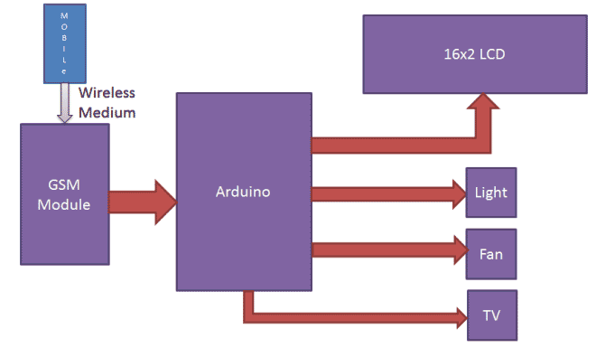 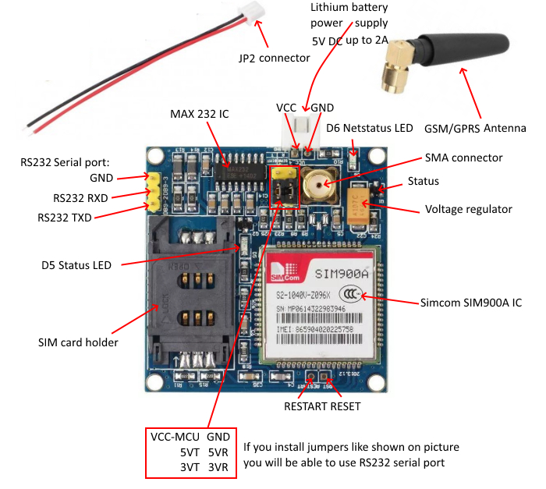

Components

* Arduino UNO
* GSM Module
* ULN2003
* Relay 5 volt
* Bulb with holder
* Connecting wires
* Bread board
* 16x2 LCD
* Power supply
* Cell phone

Application

The GSM technology is used which uses mobile stations, base substations, and network systems

In weather stations

Used in transporting vehicles and GPS positionng

Vending machines

Used in transformer station

Objective

**During This activity ,you will help students to achieve following objectives**

**1.** Understanding the principle and operation of GSM

2. Design algorithm and flowchart home automation using GSM

3. Programming GSM Module using Arduino uno

4. Interfacing GSM Module with Arduino uno

Programming steps

1. Include library for LCD
2. Defines data and control pin for LCD
3. Check checks whether any serial data is coming by checking Serial.available
4. Read the data that comes serially bySerial.read
5. Compared receive string with already defined string.
6. If receive string is different , perform appropriate command function

Program

#include<LiquidCrystal.h>  
LiquidCrystal lcd(6,7,8,9,10,11);

#define Fan 3  
#define Light 4  
#define TV 5

int temp=0,i=0;  
int led=13;

char str[15];  
void setup()  
{  
  lcd.begin(16,2);  
  Serial.begin(9600);  
  pinMode(led, OUTPUT);  
   pinMode(Fan, OUTPUT);  
    pinMode(Light, OUTPUT);  
     pinMode(TV, OUTPUT);  
    
  lcd.setCursor(0,0);  
  lcd.print("GSM Control Home");  
  lcd.setCursor(0,1);  
  lcd.print("   Automaton    ");  
  delay(2000);  
  lcd.clear();  
  lcd.print("Circuit Digest");  
  delay(1000);  
  lcd.setCursor(0,1);  
  lcd.print("System Ready");  
  Serial.println("AT+CNMI=2,2,0,0,0");  
  delay(500);  
  Serial.println("AT+CMGF=1");  
  delay(1000);  
  lcd.clear();  
  lcd.setCursor(0,0);  
  lcd.print("Fan   Light  TV ");  
  lcd.setCursor(0,1);  
  lcd.print("OFF    OFF   OFF ");   
}

void loop()  
{  
  lcd.setCursor(0,0);  
  lcd.print("Fan   Light  TV");  
  if(temp==1)  
  {  
    check();  
    temp=0;  
    i=0;  
    delay(1000);  
  }  
}

 void serialEvent()   
 {  
  while(Serial.available())   
  {  
    if(Serial.find("#A."))  
    {  
      digitalWrite(led, HIGH);  
      delay(1000);  
      digitalWrite(led, LOW);  
      while (Serial.available())   
      {  
      char inChar=Serial.read();  
      str[i++]=inChar;  
      if(inChar=='*')  
      {  
        temp=1;  
        return;  
      }   
      }   
    }  
   }  
 }

void check()  
{  
   if(!(strncmp(str,"tv on",5)))  
    {  
      digitalWrite(TV, HIGH);  
      lcd.setCursor(13,1);   
      lcd.print("ON    ");  
      delay(200);  
    }    
     
   else if(!(strncmp(str,"tv off",6)))  
    {  
      digitalWrite(TV, LOW);  
      lcd.setCursor(13,1);   
      lcd.print("OFF    ");  
      delay(200);  
    }  
    
    else if(!(strncmp(str,"fan on",5)))  
    {  
      digitalWrite(Fan, HIGH);  
      lcd.setCursor(0,1);   
      lcd.print("ON   ");  
      delay(200);  
    }  
   
    else if(!(strncmp(str,"fan off",7)))  
    {  
      digitalWrite(Fan, LOW);  
      lcd.setCursor(0,1);   
      lcd.print("OFF    ");  
      delay(200);  
    }  
   
    else if(!(strncmp(str,"light on",8)))  
    {  
      digitalWrite(Light, HIGH);  
      lcd.setCursor(7,1);   
      lcd.print("ON    ");  
      delay(200);  
    }  
   
    else if(!(strncmp(str,"light off",9)))  
    {  
      digitalWrite(Light, LOW);  
      lcd.setCursor(7,1);   
      lcd.print("OFF    ");  
      delay(200);  
    }   
      
    else if(!(strncmp(str,"all on",6)))  
    {  
      digitalWrite(Light, HIGH);  
      digitalWrite(Fan, HIGH);  
      digitalWrite(TV, HIGH);  
      lcd.setCursor(0,1);   
      lcd.print("ON     ON    ON  ");  
      delay(200);  
    }  
   
    else if(!(strncmp(str,"all off",7)))  
    {  
      digitalWrite(Light, LOW);  
      digitalWrite(Fan, LOW);  
      digitalWrite(TV, LOW);  
      lcd.setCursor(0,1);   
      lcd.print("OFF   OFF    OFF  ");  
      delay(200);  
    }       
}

Hardware instruction

1.connect transmitter pin(tx) of gsm module to receiver pin (rx) of Arduino and recever pin (rx ) to the transmitter pin of Arduino to establish communicaton

2.connect VCC and GND pin gsm module to supply voltage pi of Arduino

3.set following connection between motor driver IC ULN 2003 input pins and arduno

Digital pin D3- input pin 1(1B)

Digital pin D4- input pin 1(2B)

Digital pin D4- input pin 1(3B)

4.connect outputpin of ULN 2003 such as

Pin 16(1C) –relay 1 for tv

Pin 15(2C) –relay 2 for light

Pin 14(3C) –relay 3 for fan

5.connect VSSand R/W pin of LCD to ground an

6.connect enable and rs pin to D6 & D7

7.connect data pin s of LCD (D7,D6,D5,D4) to the digital inut pin (D11,D10,D9,D8)

